Topology
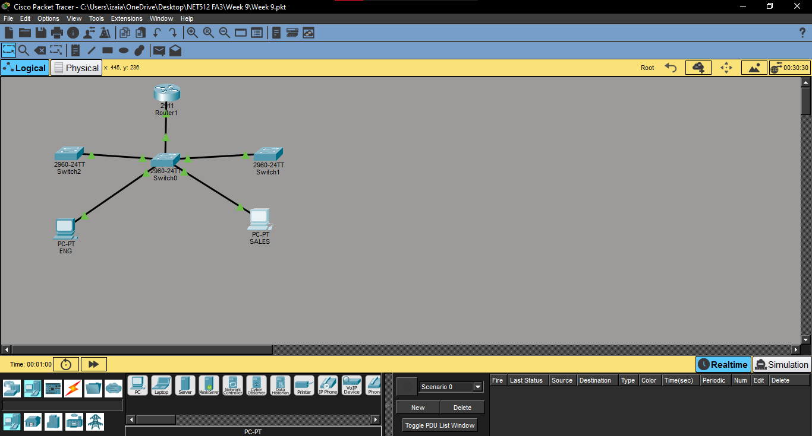

VLANs
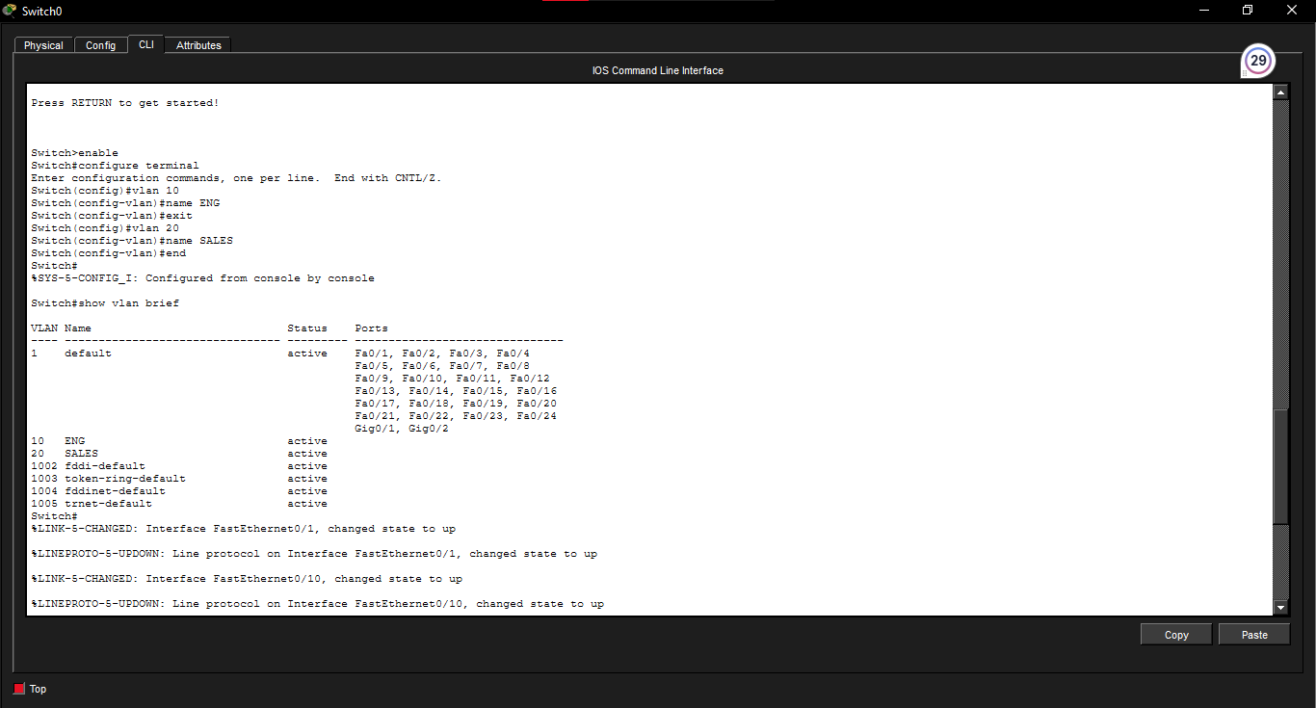

Ports assigned:
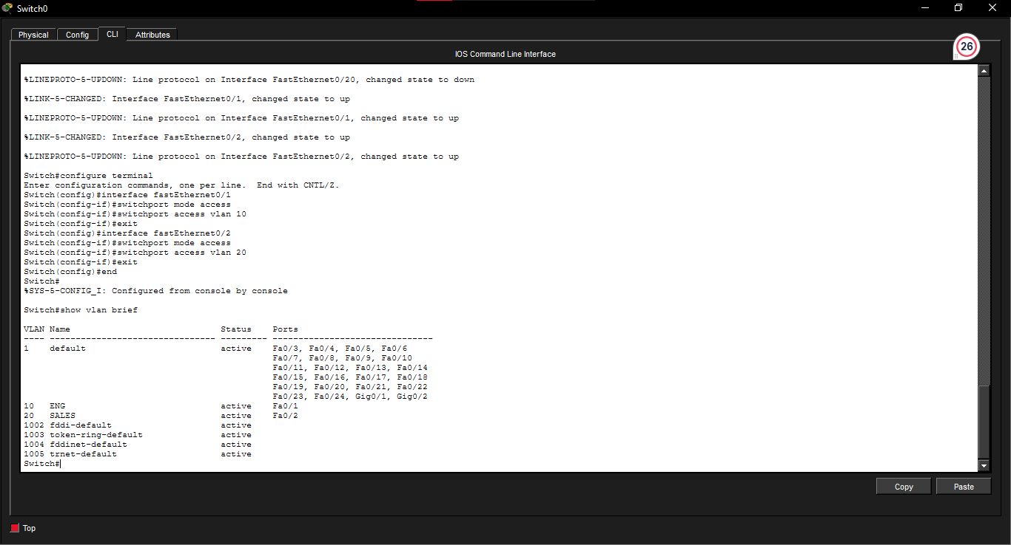
Trunks Working
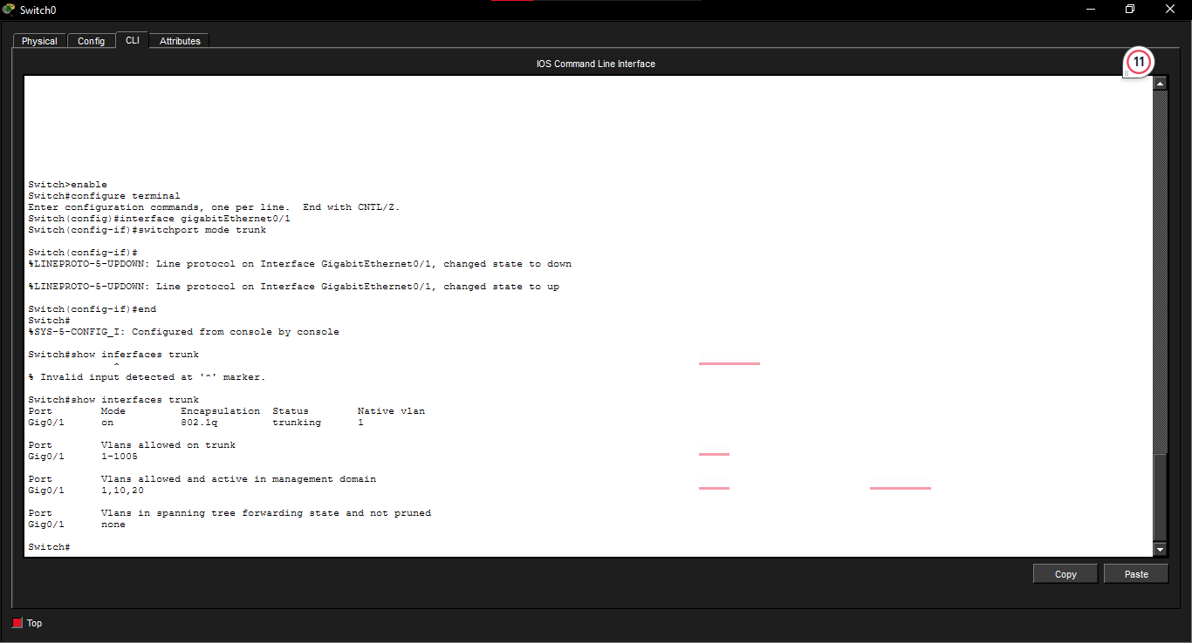

Router configuration
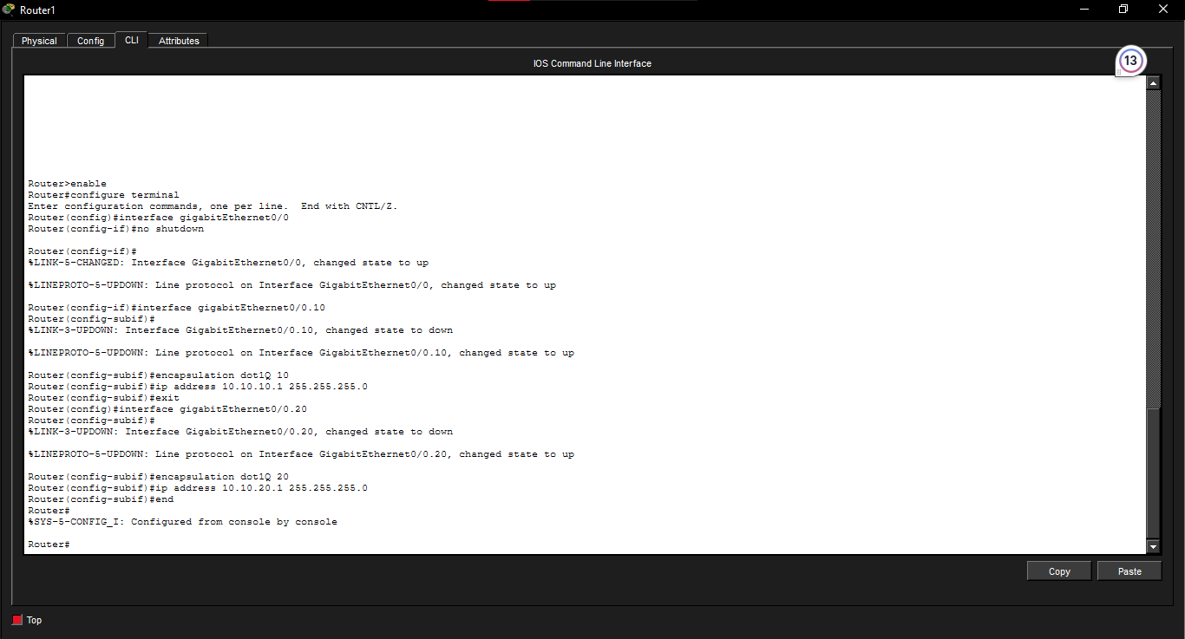

PC Configuration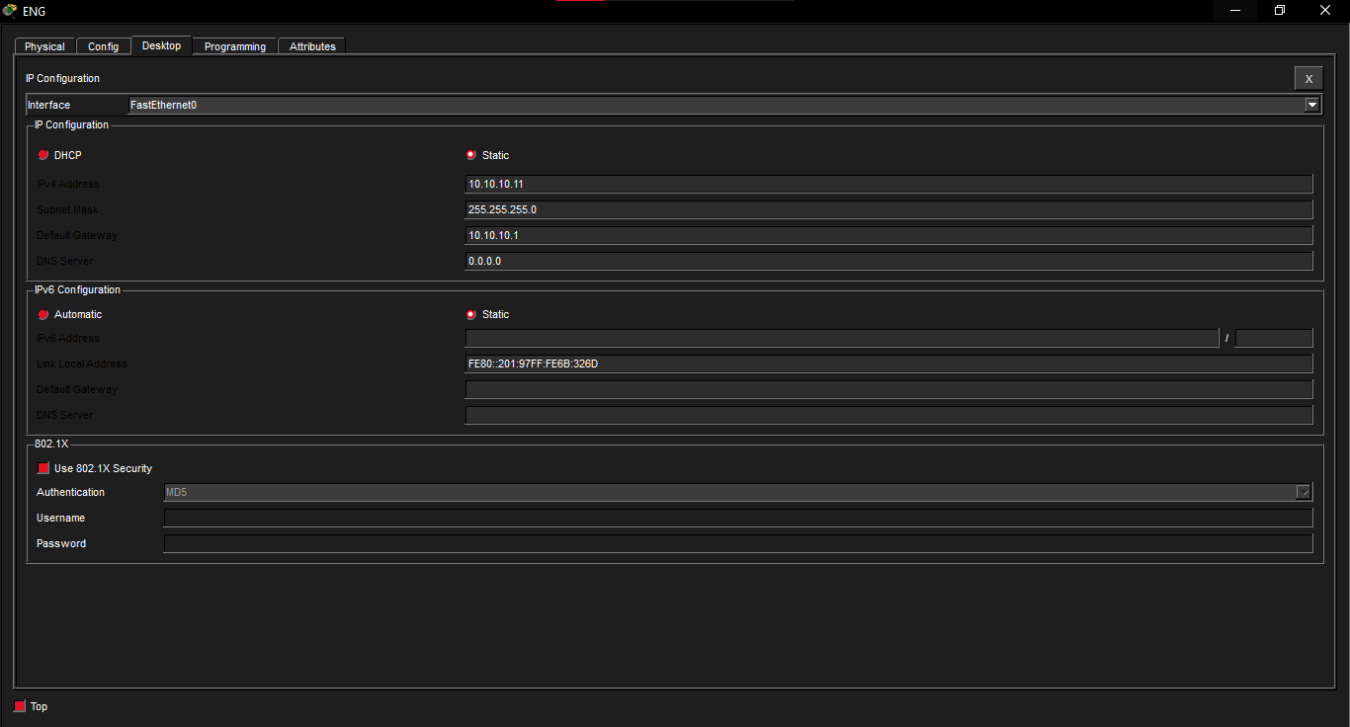

Successful ping
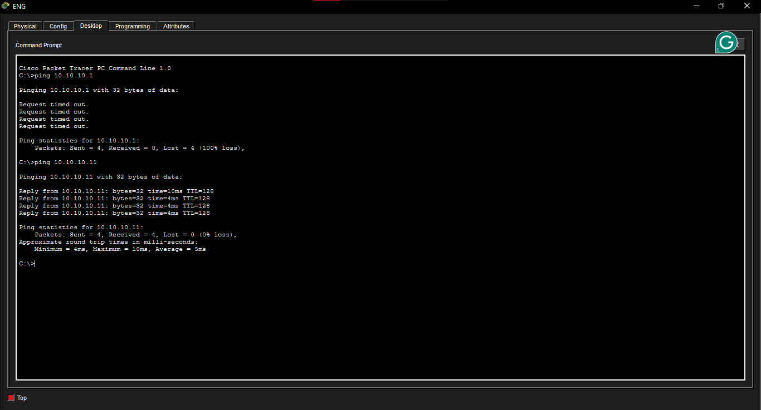

SALES successful ping
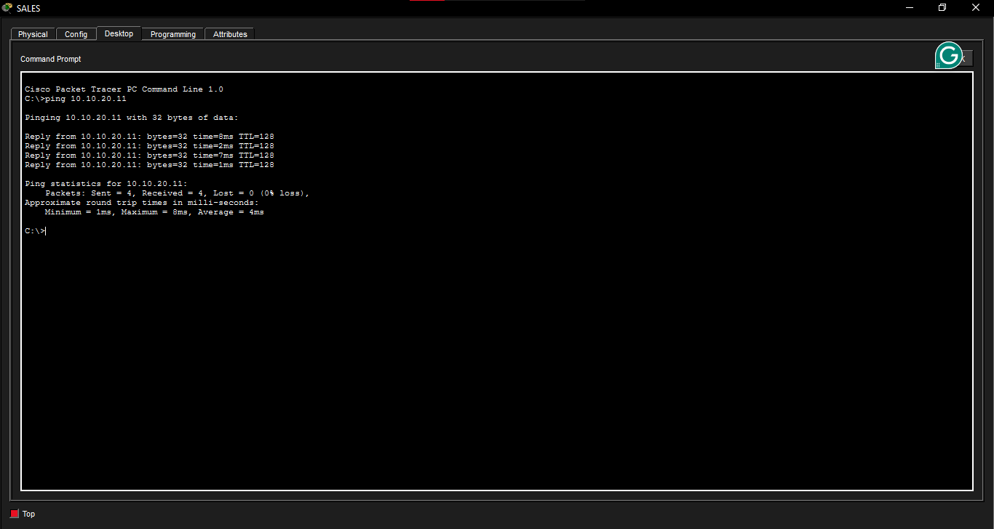

Reflection question
A Layer 3 switch can route traffic between VLANs directly and efficiently. It is suitable for large networks because it reduces the need to send inter-VLAN traffic through an external router.

